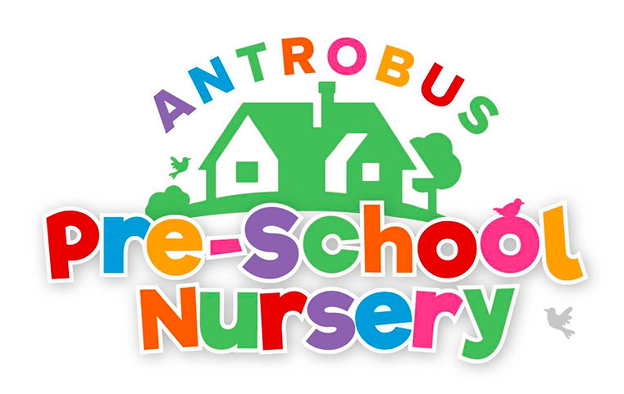
Term Dates 2023/2024
Autumn Term 2023
Nursery Opens after annual closure: Monday 4th September
Nursery Closes to term time only children: Friday 20th October (Half Term)
Nursery Opens to term time only children: Monday 30th October
Nursery Closes for term time only children: Friday 15th December (Christmas Holidays)
Nursery Closes to ALL children for annual Christmas Closure: Friday 22nd December

Spring Term 2024
Nursery Opens to ALL children: Wednesday 3rd January 2024
Nursery Closes to term time only children: Friday 16th February
Nursery reopens for term time only children: Monday 26th February
Nursery closes for term time only children: Thursday 28th March (Spring holiday)

Summer term 2024
Nursery reopens to term time only children: Monday 15th April
Nursery closed to term time only children: Friday 24th May (half term)
Nursery reopens to term time only children: Monday 10th June
Nursery closes for term time only children: Friday 26th July (Summer Holidays)
SUMMER CLOSURE WEEKS 2024:
Nursery Closes for our 2 week closure: W/C 29th July & W/C 5th August
Nursery reopens to full year children: 12th August
Nursery reopens to ALL children: TBC

Bank Holidays:
Friday 29th March: Good Friday, Monday April 1st: Easter Monday, Monday May 6th: May Bank Holiday
Monday May 27th: Spring Bank Holiday, Monday August 26th: Summer Bank Holiday (this is within our two week Summer closure)

